Ideation Phase
Brainstorm & Idea Prioritization Template

Date | 28 june 2025
Team ID | NM2025TMID00021
Project Name | Streamlining Ticket Assignment for Efficient Support Operations
Maximum Marks | 4 Marks

Streamlining Ticket Assignment for Efficient Support Operation Template:
This guided project demonstrates how to streamline and automate the process of ticket assignment to enhance operational efficiency in support systems. It begins by analyzing how tickets are currently created and distributed among support agents. A rule-based or AI-driven assignment model is then designed to automatically allocate tickets based on factors like category, priority, agent expertise, and workload.
This ensures fair ticket distribution, faster responses, and improved customer satisfaction while minimizing manual intervention and delays. The workflow also includes a validation test to ensure that tickets are correctly routed, reassigned, and tracked without loss of accountability. This helps administrators maintain consistent service quality and optimize resource utilization.
Step-1: Team Gathering, Collaboration and Select the Problem Statement
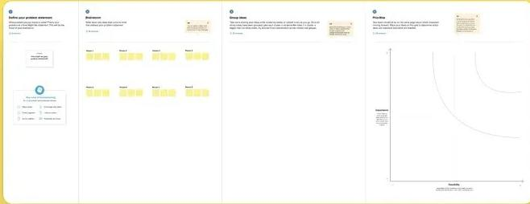

Reference: https://www.mural.co/templates/brainstorm-and-idea-prioritization

Step-2: Brainstorm, Idea Listing and Grouping
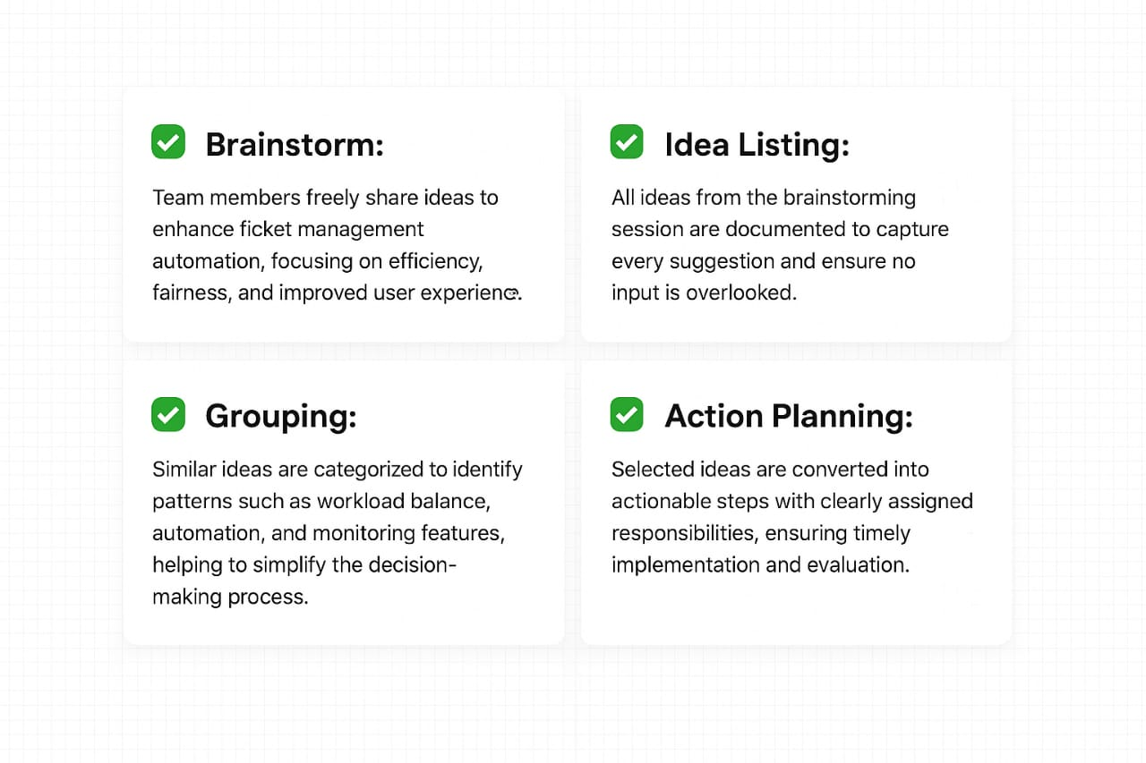

✅ Brainstorm:
Team members freely share ideas to enhance ticket management automation, focusing on efficiency, fairness, and improved user experience.
✅ Idea Listing:
All ideas from the brainstorming session are documented to ensure that even minor suggestions are captured for future enhancement.
✅ Grouping:
Similar ideas are categorized to identify patterns such as workload balance, automation, and monitoring features, helping to simplify the decision-making process.
✅ Action Planning:
Selected ideas are converted into actionable steps with clearly assigned responsibilities, ensuring timely implementation and evaluation.

Step-3: Idea Prioritization
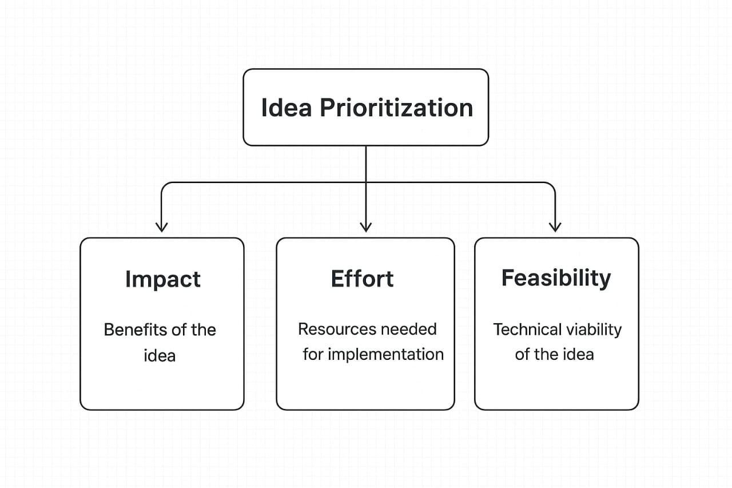

7 Steps to Streamline Ticket Assignment for Efficient Support Operation:

- Identify Ticket Sources – Analyze all incoming ticket channels (email, chat, portal).
- Categorize & Prioritize – Assign priorities based on urgency and type.
- Define Assignment Rules – Create logic for expertise, workload, and SLAs.
- Implement Auto-Assignment Engine – Automate ticket routing.
- Enable Real-Time Monitoring – Track ticket progress and workload balance.
- Provide Manual Override Option – Allow admin intervention when needed.
- Review & Optimize – Use analytics to continuously improve assignment rules.

